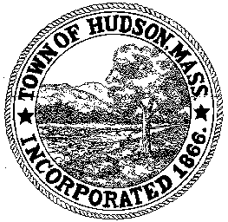

CONSERVATION COMMISSION
78 Main Street, Hudson, MA 01749
(978) 568-2020

Paul Byrne, Chairman W. Minot Wood, Vice Chairman David Esteves, Member

Terrence Joyce, Member Leif Longtine, Member Joseph Rodrigues, Member Al Tashian, Member

Agenda
August 6, 2009 7:00 P.M.

- Preliminaries
  - Open Meeting
  - Roll Call
1.3 Additions or Deletions to the agenda

2.0 Hearings and Appointments
2.1 RDA 385
Applicant: Lawrence Sherman
Location: 6 Lower Road
Project Description: The removal of 2 trees that are less than 20” from the house and in danger of falling.

3.0 General Business
3.1 Voucher 072309 $1800.00

4.0 Adjournment

